Devin Hardy

[Dhardy2@my.athens.edu](mailto:Dhardy2@my.athens.edu)

00076619

Exercise 1:

Plans for my home page (index.html):

* Center the header
* Change the background color of the body to red
* Change color of segments that clash
* Add some borders to segments
* Align some text next to pictures
* Formed a grid to provide organization

Plans for my second home page:

* Center the header
* Change the background color of the body
* Add some borders to segments
* Made the forms smaller to take up less space

Exercise 2:

Index Validation: (Leaving this error as it is CSS related)

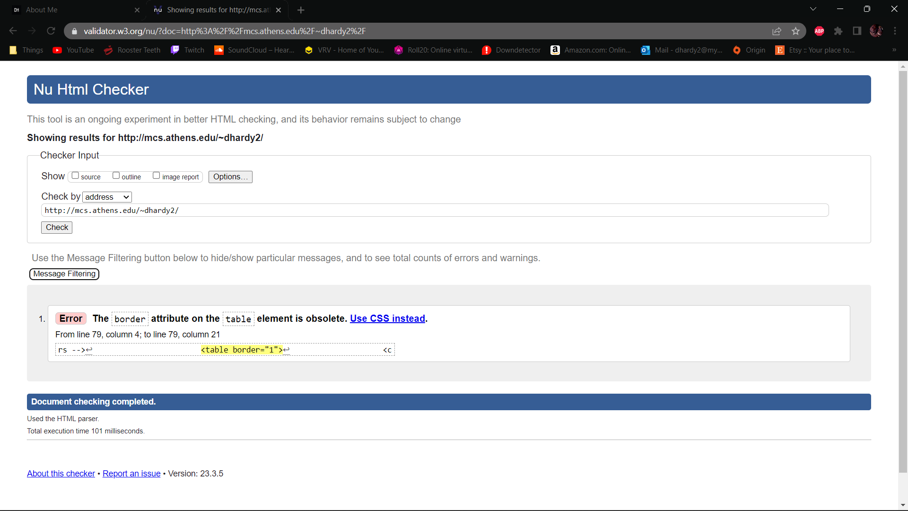

Index Live Site:

Exercise 3:

HardyindexGrid Validation:

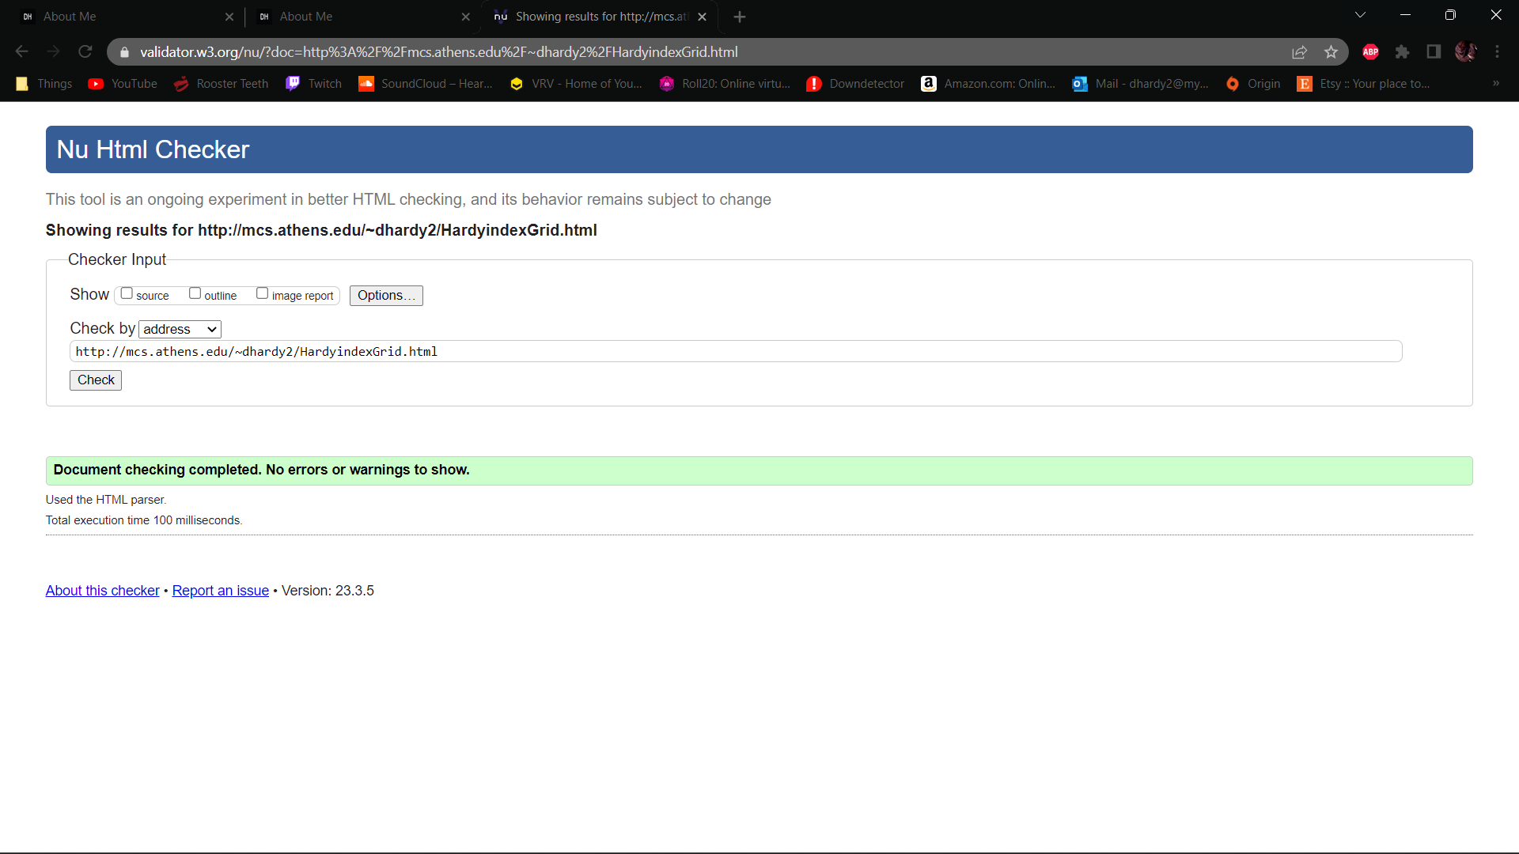

CSS Validation:

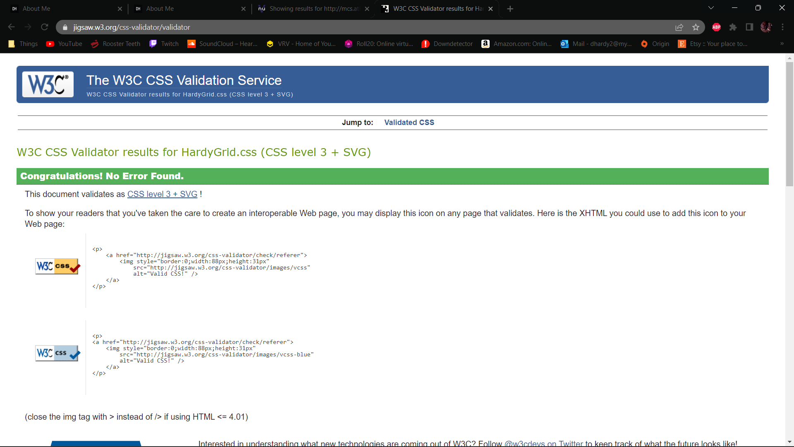

HardyindexGrid Live Site:

Wave Accessibility:

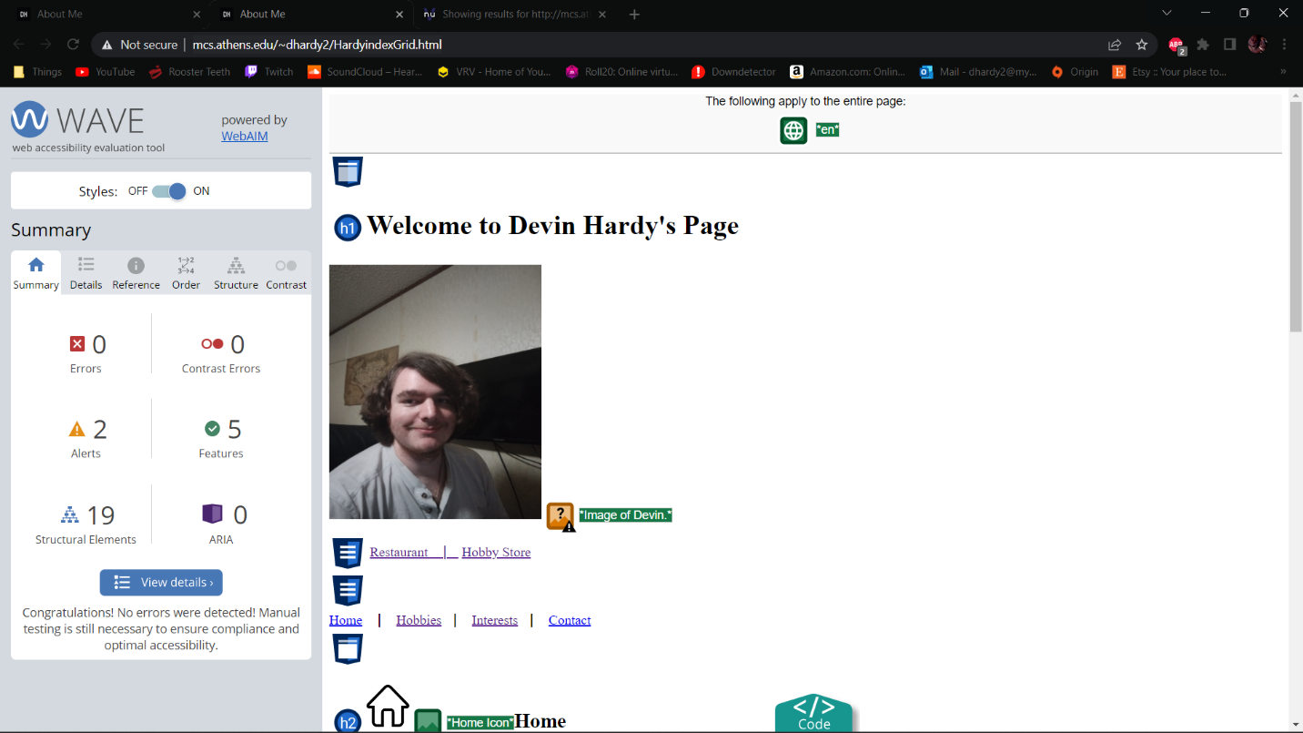

Exercise 4:

HardyFormGrid Validation:

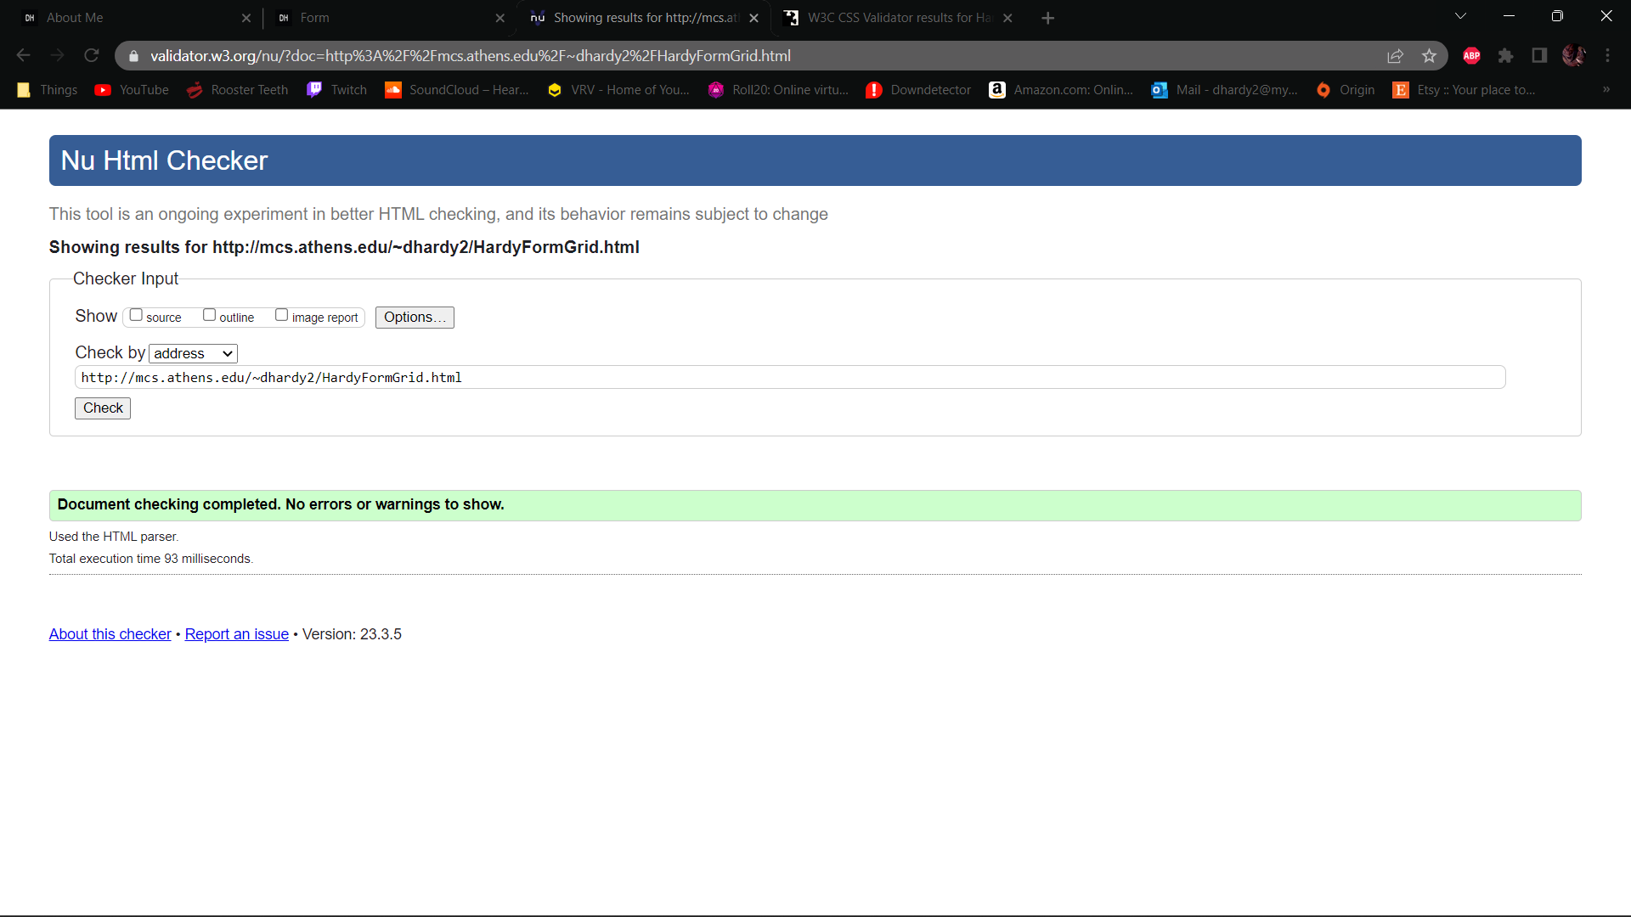

CSS Validation:



HardyFormGrid Live Site:

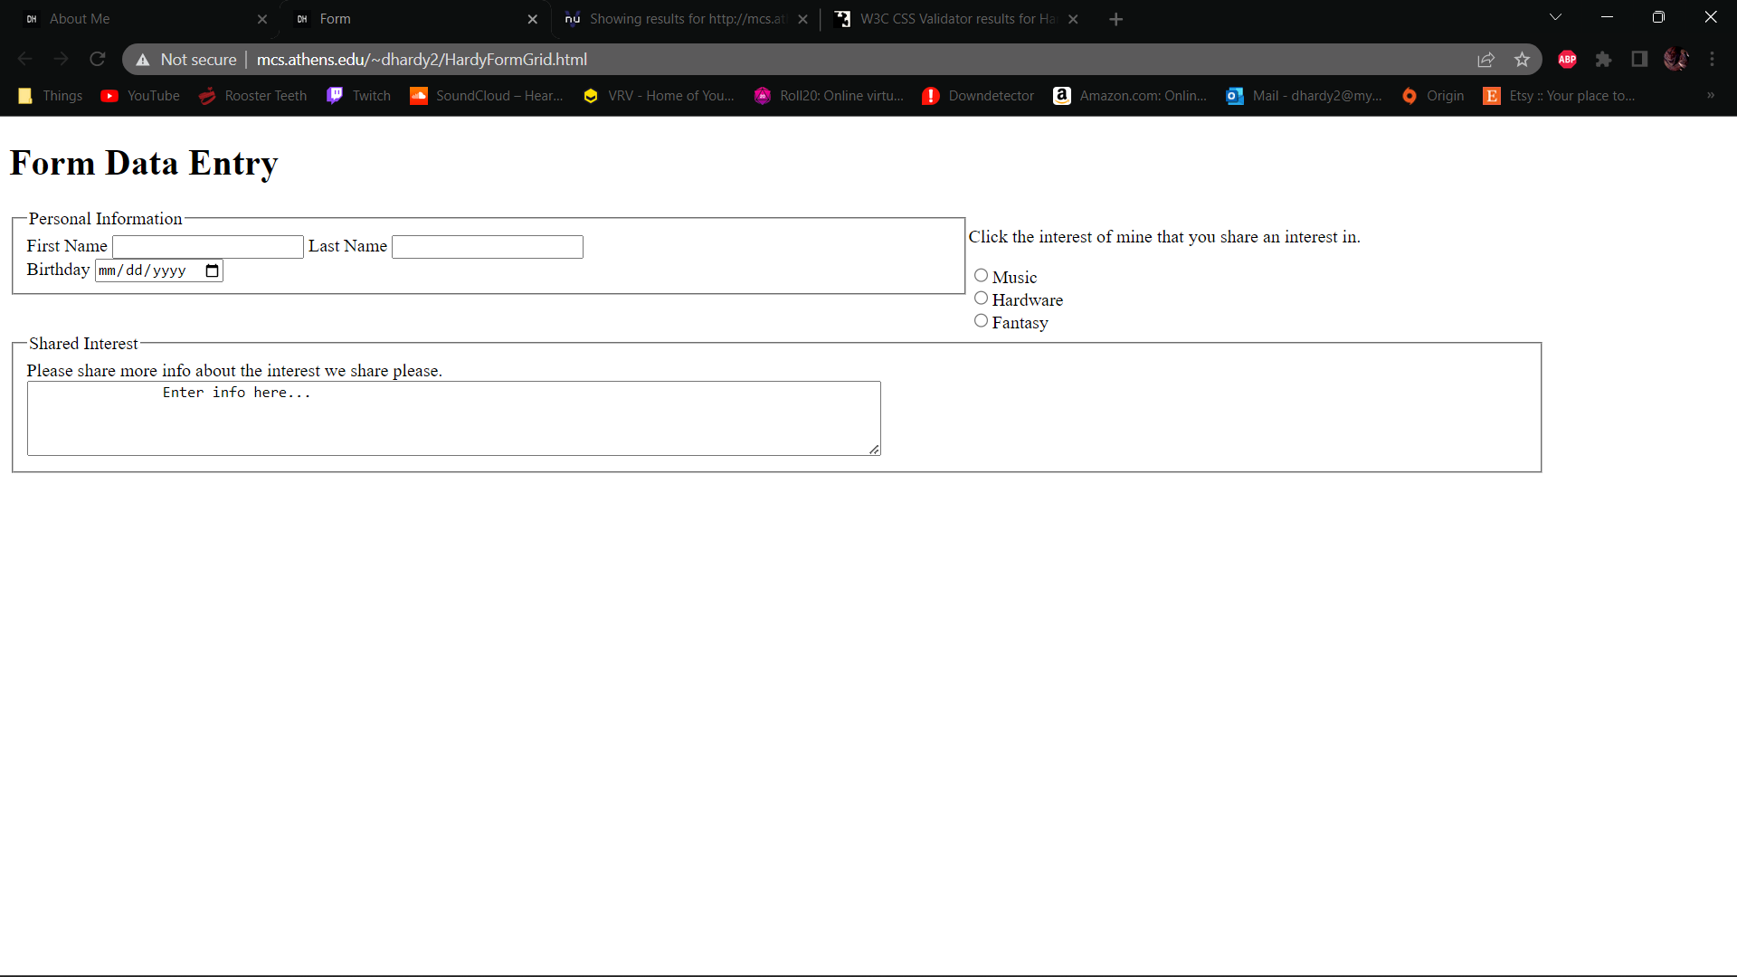

Wave Accessibility:

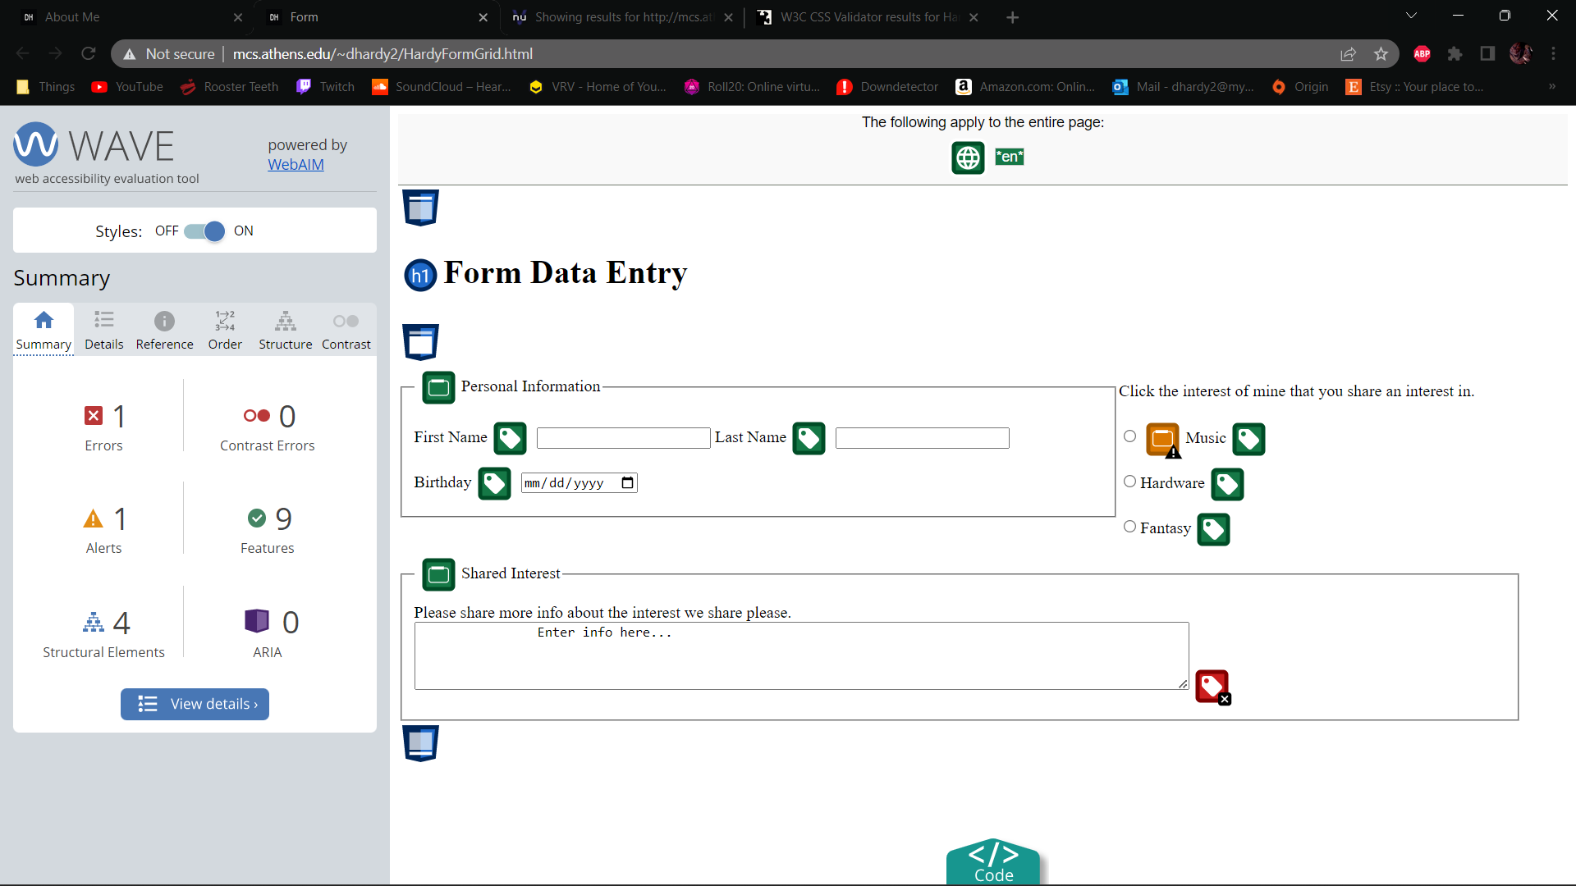

Exercise 5:

HardyindexGrid2 validation:

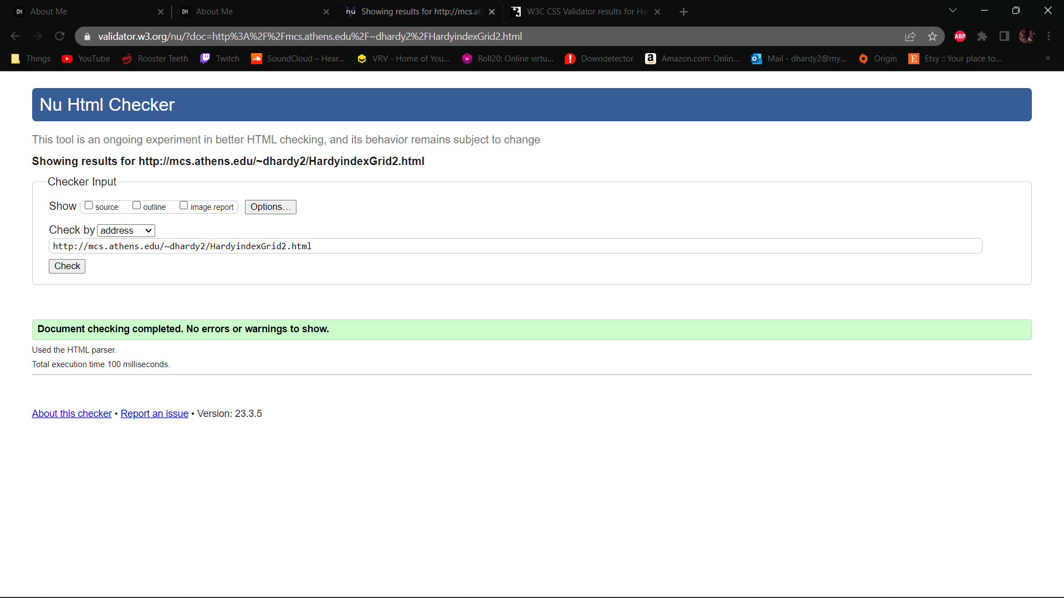

HardyRelativeGrid validation:

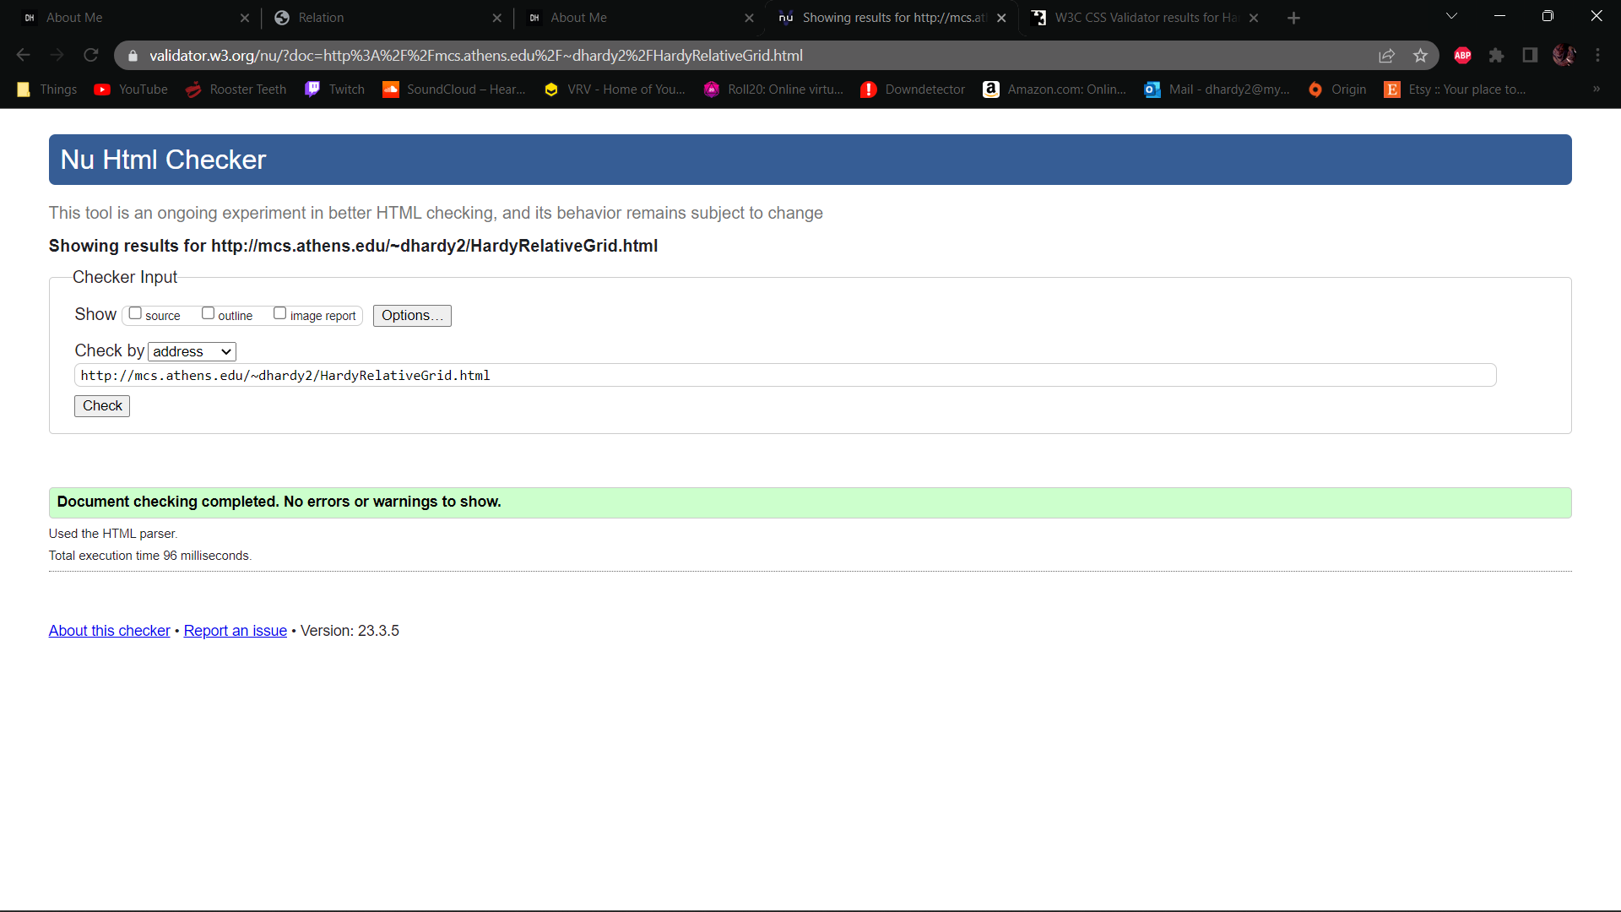

CSS validation:

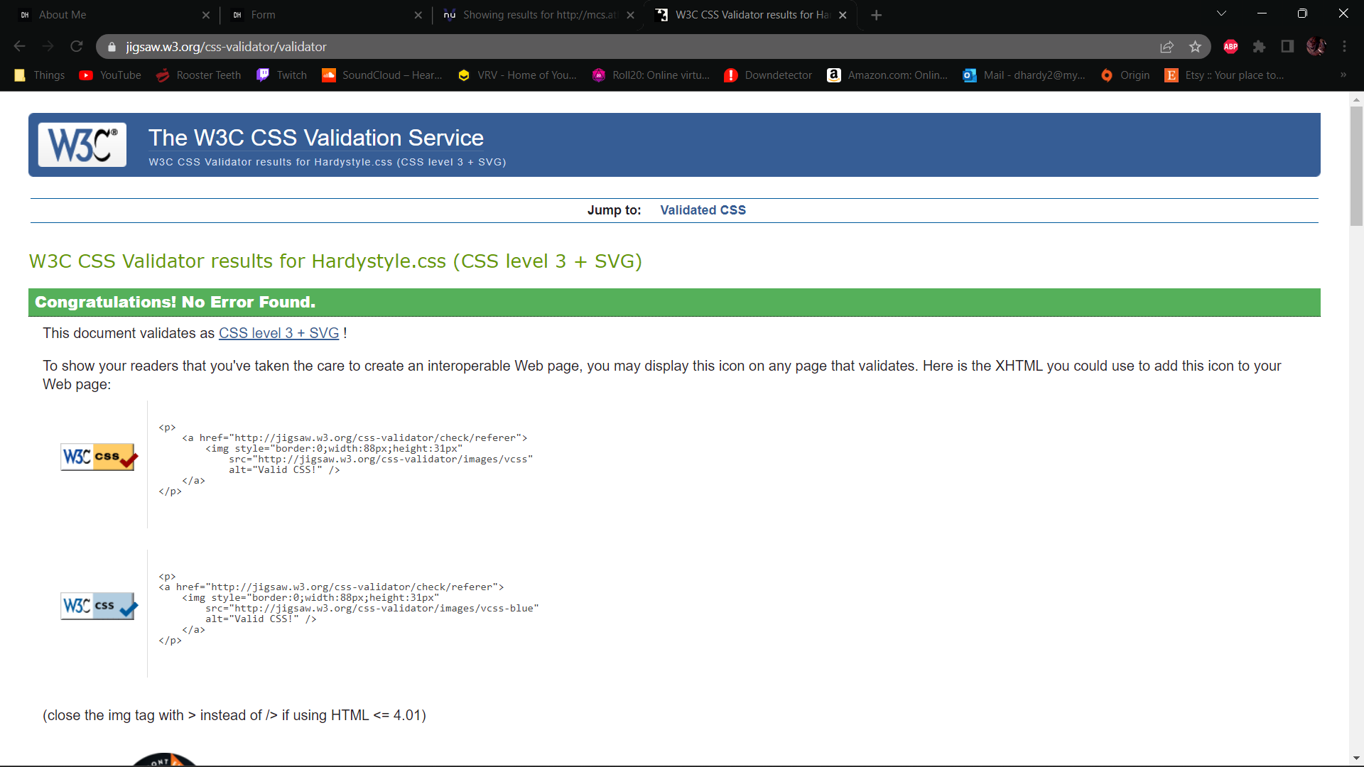

HardyindexGrid2 Live:

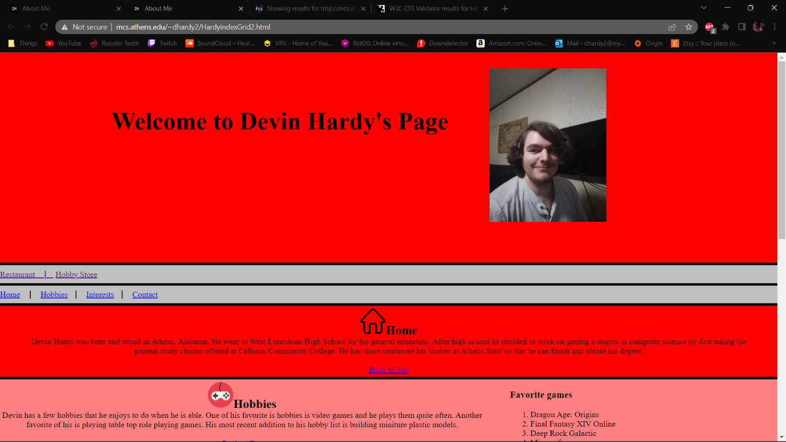

HardyRelativeGrid Live:

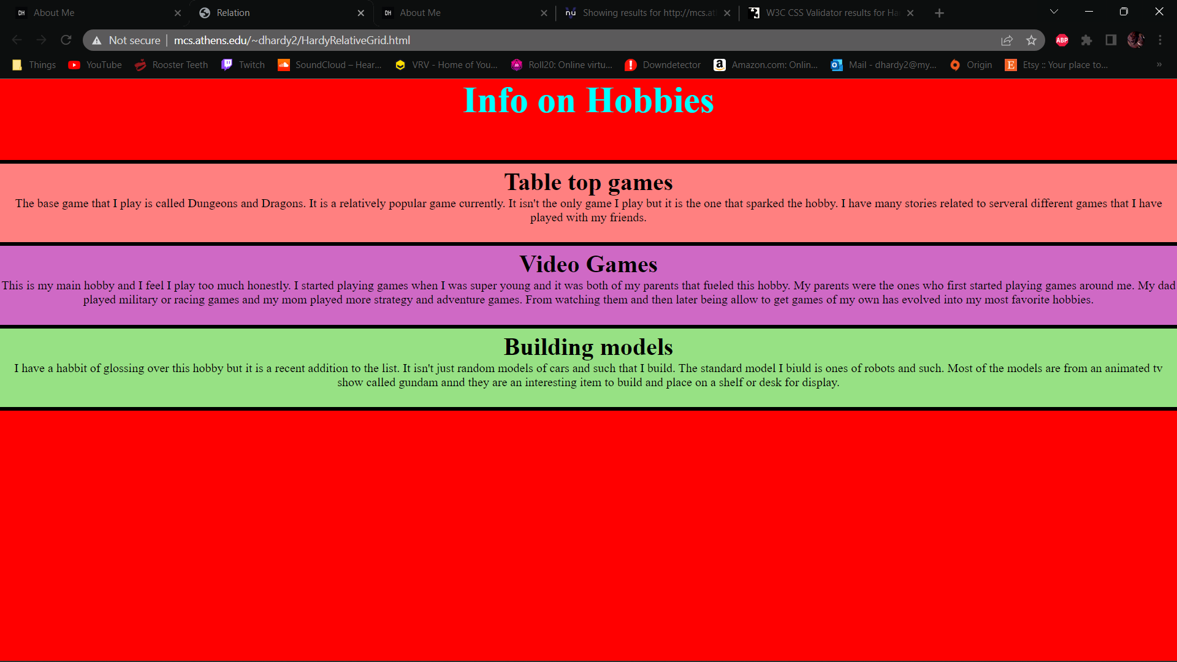

HardyindexGrid2 Accessibility:

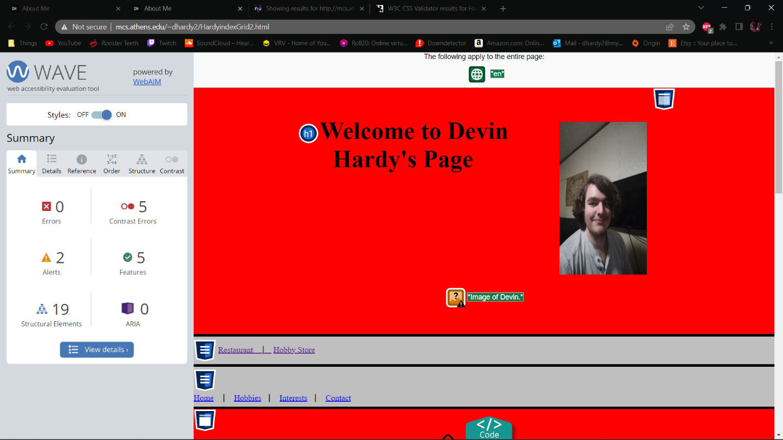

HardyRelativeGrid Accessiblity:

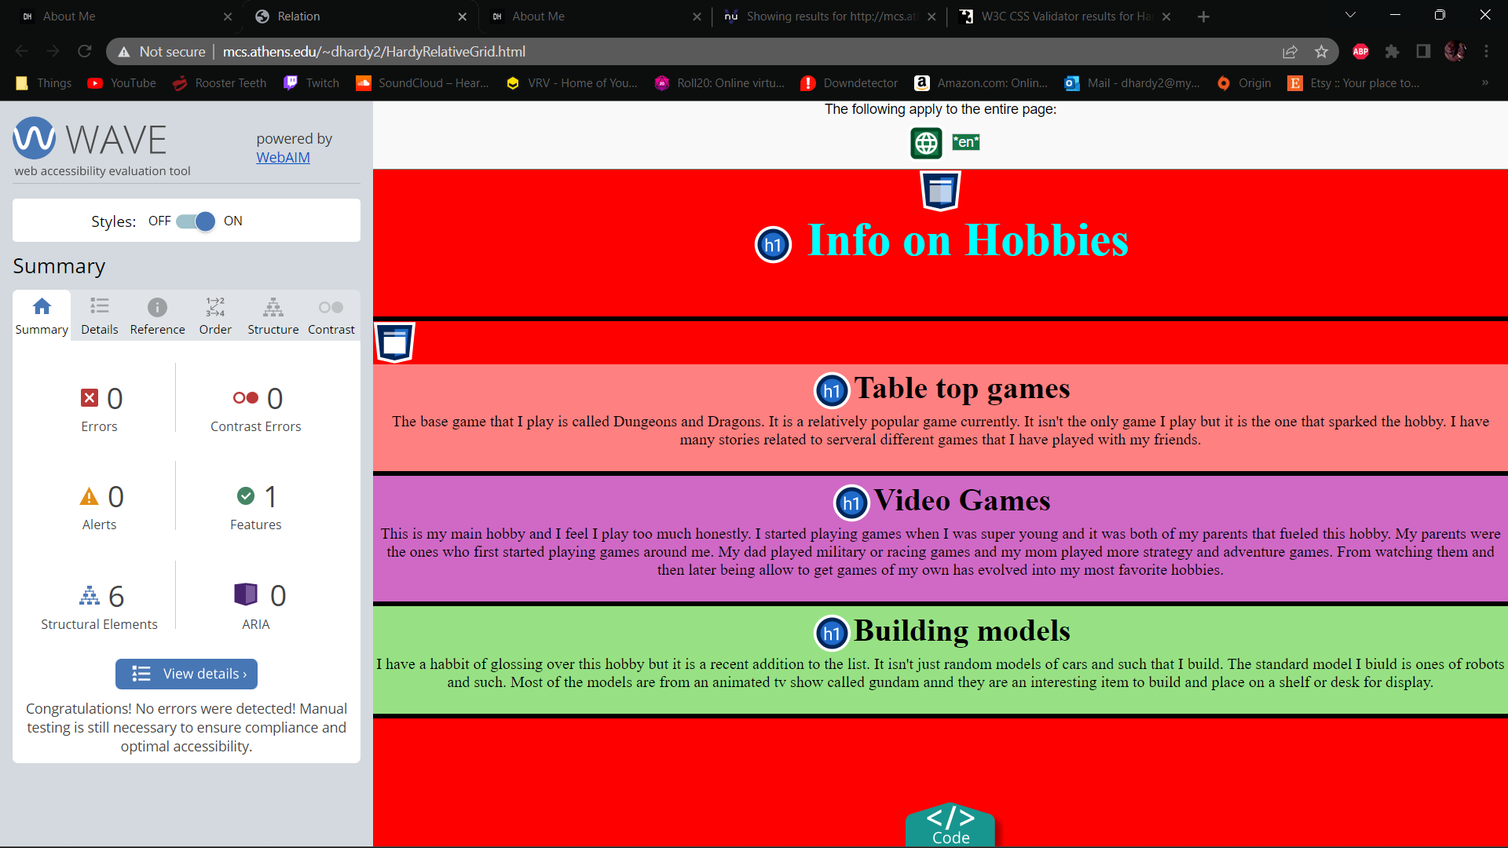

Exercise 6:

Index validation: (CSS error: leaving it alone as this page does have CSS yet)

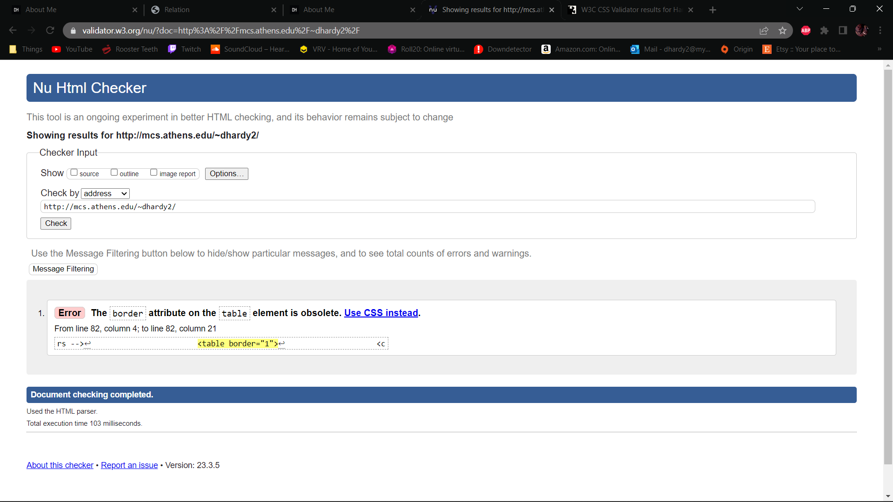

Index Live:

